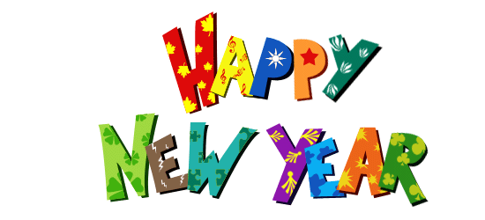

Knockbreda Nursery School

January 2016 Newsletter

Dear Parents and Carers

We hope that you and your child had a wonderful Christmas break and wish you all a Happy New Year! Many thanks for the lovely gifts and cards we received before the Christmas break, they were sincerely appreciated by us all. We have enjoyed welcoming the children back to school and hearing all about their exciting Christmas holidays and of course, their favourite gifts! Thank you also for supporting our Christmas Jumper Day, Nursery raised almost £50 for Text Santa (donations shared between Macmillan Cancer Support and Make-a-wish UK and Save the Children).

**Themes and topics**

This half-term, our learning topic is The Cold Lands (Arctic and Antarctic), including Winter. The learning across our classrooms will focus on this topic, with many exciting activities taking place. We will be enjoying melting ice in the water tray, taking part in a seasonal investigation outdoors, painting and creating snowmen and learning all about the season of Winter. We will be welcoming Mr Hullabaloo to Nursery this month and he will be performing a wonderful winter show for us all! As part of our physical development and movement curriculum, we will also enjoy a yoga session with Aisling, at the end of January. We have included some of the songs and rhymes that we will be learning through our topic, so that you can share them with your child at home.

Each week we will be focusing on a shape, learning its name and counting the number of sides and corners each shape has. We will be learning about the square, circle, rectangle and triangle this month. Please support this at home through the songs and rhymes included in shape booklet (accompanying this newsletter) and please feel free to send in some shapes from around your home, to enhance our shape table (named please).

**Important information**

* Please note that the school’s Talk 21 email account has now closed. All email correspondence should be sent to [info@knockbredanursery.co.uk](mailto:info@knockbredanursery.co.uk)
* As we are now using all of our outdoor play areas on a daily basis, please ensure that your child can put on/ take off their own coats, shoes and wellies. Please make sure that all children have a warm coat (with a hood) each day and that scarves, hats and mittens are in your child’s classroom tray. **Please clearly name all items and help your child become independent in putting on/ taking off their shoes, wellies, coats, hats and gloves.**
* It would be greatly appreciated if each child could contribute a box of tissues each term. If your child brushes their teeth at school, please send in a new toothbrush and toothpaste for this term.
* There is a school fund charge of £30 for the first two terms and £40 for the summer term (£100 for the year, ie 54p per day). This covers your child’s daily drink, fruit and bread based snack, weekly baking, play dough ingredients, Christmas and end of year parties, monthly Music Club, visitors who come into school each term, books for the school library and other small items not covered by school’s delegated budget. School fund for this term (£30) should be paid by 29th January 2016. Cheques should be made payable to Knockbreda Nursery School (School Fund Account) and posted in the white postbox at the main reception door. **Please note that due to tax regulations for Childcare vouchers, payments can no longer be accepted in this form (from this term onwards).**
* In case of closure due to snow, school will contact parents via email directly from the school account. If you have not provided school with an email address, please check the school website for closure information and also BBC News NI Live for details.

**Winter**

**Songs and Rhymes**

C:\Program Files\Microsoft Office\MEDIA\CAGCAT10\j0299587.wmf

The Cold Lands

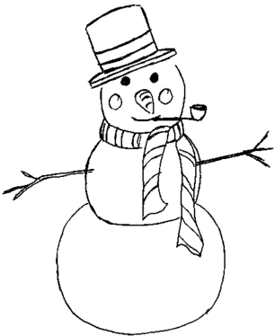

**Chubby Snowman**

**There was a chubby snowman**

(hold arms around body)

**Who had a carrot nose**

 (with one hand make a pinching motion and pull it out from your nose to insinuate a carrot shape)

**Along came a bunny**

(hold up two fingers and make a hopping motion)

**And what do you suppose?**

 (shrug shoulders)

**That hungry little bunny**

 (rub tummy)

**Was looking for his lunch**

(hold one hand over eyes and look around)

**He ate that snowman's nose....   
Nibble, nibble CRUNCH!**

(use hand to make a chomping mouth actions at your nose)

**5 Little Penguins**

5 Little penguins slipping on the ice

            One fell down, that’s not nice.

Mama called the doctor and the doctor said,

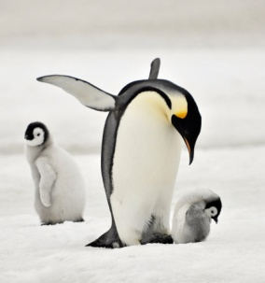            “No more penguins slipping on the ice.”

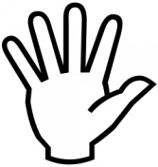4 Little penguins slipping on the ice

            One fell down, that’s not nice.

Mama called the doctor and the doctor said,

            “No more penguins slipping on the ice.”

3 Little penguins slipping on the ice

            One fell down, that’s not nice.

Mama called the doctor and the doctor said,

            “No more penguins slipping on the ice.”

2 Little penguins slipping on the ice

            One fell down, that’s not nice.

Mama called the doctor and the doctor said,

            “No more penguins slipping on the ice.”

1 Little penguin slipping on the ice

            One fell down, that’s not nice.

Mama called the doctor and the doctor said,

            “No more penguins slipping on the ice.”

No more penguins slipping on the ice

            None fell down, that’s real nice.

Mama called the doctor and the doctor said,

            “No more penguins slipping on the ice.”

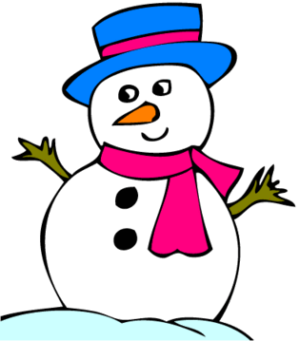

**Five Little Snowmen**

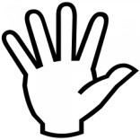Five Little snowmen sitting in the snow,

The 1st one said, “My nose is cold!”

The 2nd one said, “Let’s have some fun!”

The 3rd one said, “Look at the hot sun!”

The 4th one said, “I think we should run!”

The 5th one said, “I think I’m done!”

**The Mulberry Bush**

Here we go round the mulberry bush, the mulberry bush, the mulberry bush!

Here we go round the mulberry bush on a cold and frosty morning!

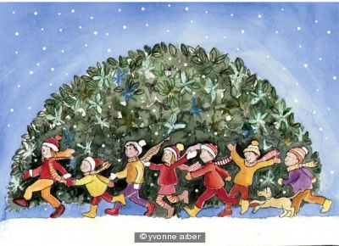

**Little Snowman**

(to the tune of I’m a little teapot)



I’m a little snowman round and fat

Here are my mittens

Here is my hat

Add a little scarf and a carrot nose

You stand so tall when the cool wind blows